Supervisor D for Process Control

* Create Python VirtualEnvironment.

virtualenv supervisor_venv

* Activate the virtual Environment

supervisor_venv/bin/activate

* Install supervisor

pip install supervisor

* Create Configuration File

echo_supervisord_conf > supervisord.conf

* Edit the config file and program to bottom of file.
* Un comment the following lines (remove ;)

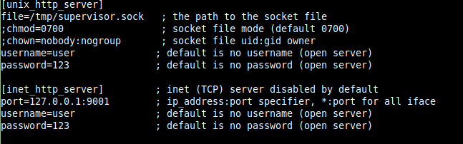

* Start Supervisor:

supervisord -n -c supervisord.conf

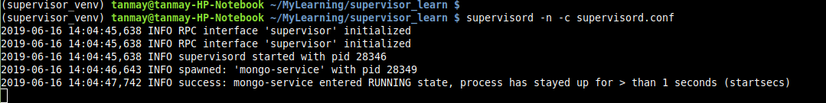

* View Supervisor in browser [http://localhost:9001](http://localhost:9001/) where you can start/stop/restart process

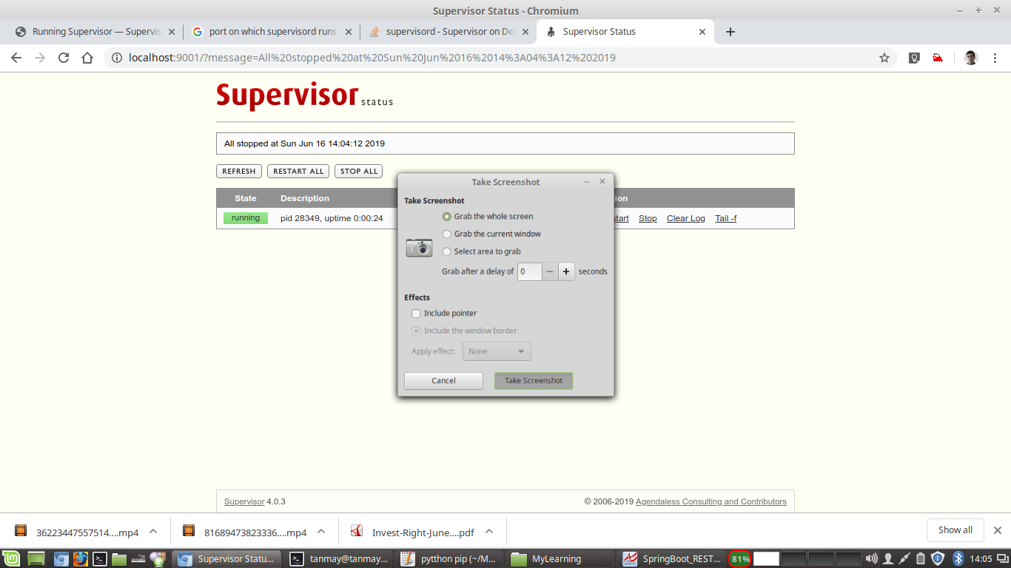

* Click tail -f to view logs of the process

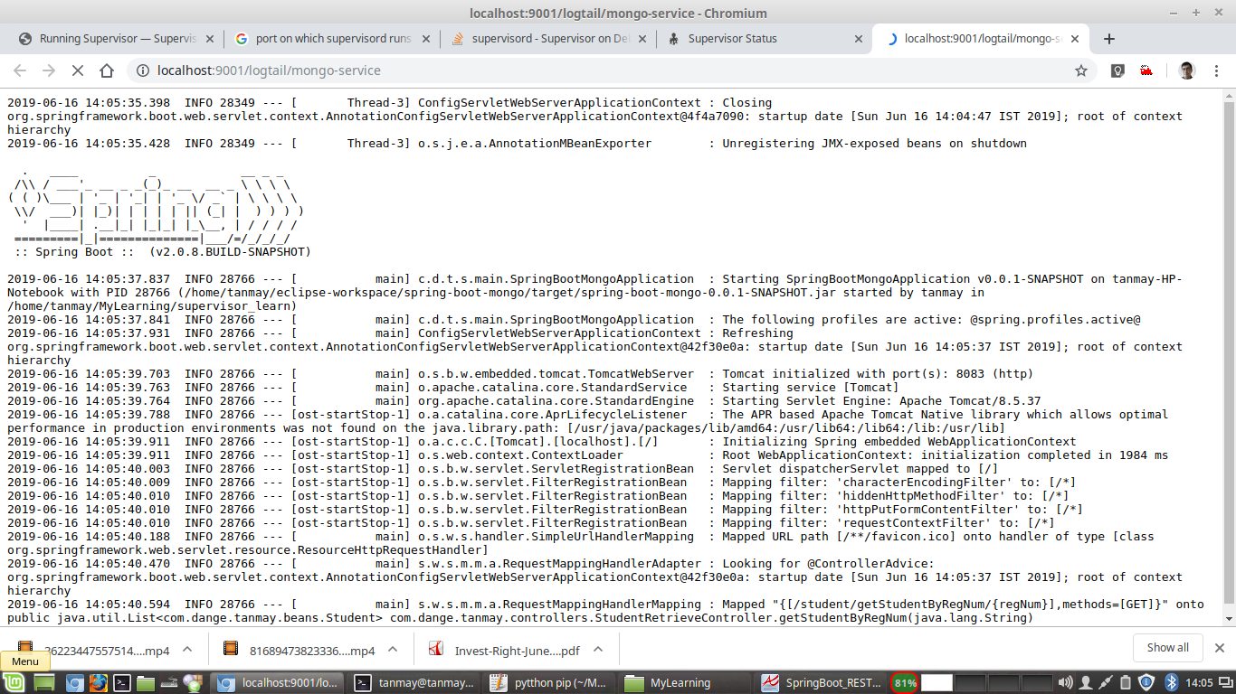

* To exit , just press Ctrl +C and deactivate the virtual environment.

